DESIGN AND CONSTRUCTION OF A DOMESTIC HYBRID DISASTER
DETECTION SYSTEM

BY

KELVIN TERTESE STEPHEN
21/58649/UE
&
WAAKAA ABSALOM TERKUMA
22/60013/DE

DEPARTMENT OF ELECTRICAL AND ELECTRONICS ENGINEERING,
JOSEPH SARWUAN TARKA UNIVERSITY, MAKURDI.

November, 2026
DESIGN AND CONSTRUCTION OF A DOMESTIC HYBRID DISASTER
DETECTION SYSTEM

BY

KELVIN TERTESE STEPHEN
21/58649/UE
&
WAAKAA ABSALOM TERKUMA
22/60013/DE

Project Submitted to the Department of Electrical and Electronics Engineering,
Joseph SarwuanTarka University, Makurdi in Partial Fulfilment of the Award of Bachelor
of Engineering in Electrical and Electronics Engineering.

November, 2026

DECLARATION
We declare that the work described in this project is original, and has not been previously submitted to any university or similar institutions for the award of any degree or certification.

Name of Candidates: KELVIN TERTESE STEPHEN
Registration Number: 21/58649/UE
Signature: ………………………………………………………………………….
Date……………………………………………………………………………...

Name of Candidates: WAAKAA ABSALOM TERKUMA
Registration Number: 22/60013/DE
Signature: ………………………………………………………………………….
Date……………………………………………………………………………...

CERTIFICATION
We, the undersigned, hereby certify that this research project presented by KELVIN TERTESE STEPHEN (21/58649/UE) and WAAKAA ABSALOM TERKUMA (22/60013/DE), is accepted as fulfilling part of the requirements for the award of the degree of Bachelor of Engineering in Electrical and Electronics Engineering.
Title: DESIGN AND CONSTRUCTION OF A DOMESTIC HYBRID DISASTER DETECTION SYSTEM

Engr. Iannah ………………………………….
Supervisor Signature/ Date

Engr. Madukwe C. A. …………………………………
Project Coordinator Signature/ Date

Engr. Dr E. T. Iorkayse …………………………………
Head of Department Signature/ Date

DEDICATION
This work is dedicated to God Almighty who sustained our lives during our study.

ACKNOWLEDGEMENT
We give all glory and thanks to Almighty God, whose grace, wisdom, and sustaining strength made the successful completion of this project possible. His guidance remained evident at every stage of this work.
We express our profound gratitude to our project supervisor, Engr. Ianna, for his unwavering commitment, professional guidance, and constructive feedback throughout the research and implementation process. His technical expertise, encouragement, and timely interventions played a significant role in shaping this project and bringing it to fruition.
Our sincere appreciation also goes to the Department of Electrical and Electronics Engineering, Joseph Sarwuan Tarka University, for providing a conducive academic environment and the necessary resources that supported this research.
We are deeply thankful to our lecturers and departmental staff for their dedication, mentorship, and contributions toward building our knowledge in intelligent systems and embedded technologies.
We also acknowledge our colleagues and friends whose suggestions, discussions, and assistance enriched the development of this work in many ways.
Above all, we extend our heartfelt appreciation to our families for their constant moral support, patience, and belief in us throughout this journey. Their encouragement remained a source of strength and motivation.

TABLE OF CONTENTS

DECLARATION 2
CERTIFICATION 3
DEDICATION 4
ACKNOWLEDGEMENT 5
TABLE OF CONTENTS 6
TABLE OF FIGURES 8
TABLE OF TABLES 9
1 INTRODUCTION 11
1.1 Background of the Study 11
1.2 Statement of the Problem 12
1.3 Aim of the Study 12
1.4 Objectives of the Study 13
1.5 Significance of the Study 13
1.6 Scope of the Study 13
2 LITERATURE REVIEW 15
2.1 Theoretical Framework 15
2.1.1 Flame Sensor 16
2.1.2 MQ-2 Gas Sensor 16
2.1.3 Water Level Sensor 17
2.1.4 ESP32 Microcontroller 18
2.1.5 SIM800L GSM Module 20
2.1.6 Buzzer 21
2.1.7 BC547 Transistor and 1N4007 Diode 22
2.2 Conceptual Framework 23
2.2.1 Power Supply Section 23
2.2.2 Sensing and Detection Unit 23
2.2.3 Control and Processing Unit 23
2.2.4 GSM Alert and Communication Unit 24
2.2.5 Alarm and Response Unit 24
2.2.6 System Interaction and Flow 24
2.3 Development of Block Diagram 25
2.4 Review of Related Empirical Studies 25
2.5 Summary of Literature Review 27
3 CIRCUIT ANALYSIS AND DESIGN 29
3.1 Introduction 29
3.2 Circuit Analysis and Design 30
3.3 Circuit Diagram 36
3.4 Programming 39
4 CONSTRUCTION, TESTING, RESULTS AND DISCUSSION 43
4.1 Introduction 43
4.2 System Construction 43
4.3 Component Testing 44
4.3.1 Flame Sensor Test 44
4.3.2 MQ-2 Gas Sensor Test 45
4.3.3 Water Level Sensor Test 46
4.3.4 SIM800L GSM Module and SMS Alert Test 47
4.4 Integrated System Testing 47
4.4.1 Boot Sequence Verification 48
4.4.2 Simultaneous and Sequential Hazard Testing 48
4.5 Discussion 49
5 SUMMARY, CONCLUSION AND RECOMMENDATIONS 51
5.1 Summary 51
5.2 Conclusion 51
5.3 Recommendations 52
REFERENCES 53
6 APPENDIX A: COMPLETE PROGRAM LISTING 55

TABLE OF FIGURES
Figure 2.1 Flame Sensor 15
Figure 2.2 Gas Sensor 16
Figure 2.3 Water Level Sensor 17
Figure 2.4 ESP32 Microcontroller 18
Figure 2.5 Sim800L GSM Module 20
Figure 2.6 Buzzer 21
Figure 2.7 BC547 Transistor 21
Figure 2.8 1N4007 Diode 21
Figure 2.9Block diagram of the hybrid domestic fire, gas, and flood detection system 24
Figure 3.1 Complete circuit diagram of the hybrid domestic detection system with GSM-based alert (Plain) 35
Figure 3.2 Complete circuit diagram of the hybrid domestic detection system with GSM-based alert (Proteus) 35
Figure 3.3 Flow Chart of the Hybrid Detection System Program Logic 37

TABLE OF TABLES
Table 2-1 ESP32 GPIO Pin Allocation for the Detection System 18
Table 3-1 Flame Sensor to ESP32 Connection 29
Table 3-2 MQ-2 Gas Sensor to ESP32 Connection 30
Table 3-3 Water Level Sensor to ESP32 Connection 31
Table 3-4 SIM800L GSM Module to ESP32 Connection 32
Table 3-5 Truth Table for Hazard Conditions and System Output Response 33

INTRODUCTION

Background of the Study
The frequency of domestic disasters, including fire outbreaks, gas leakages, and flooding, has continued to pose a serious threat to lives and property in Nigeria and many parts of the developing world. According to a statistical analysis of fire outbreaks in Lagos State, three-quarters of fatal home fires in Nigeria originate in the living room, bedroom, or kitchen, with many of these incidents attributable to undetected LPG gas leaks or electrical faults (Ahmed, 2014). The National Emergency Management Agency (NEMA) has recorded that annual floods in Nigeria over the past two decades have resulted in the loss of over 1,763 lives and damage to properties valued at nearly one billion United States dollars (Umar & Gray, 2022). These figures reveal that domestic hazards, both man-made and natural, remain a critical public safety challenge that conventional reactive responses have failed to adequately address.
The growing adoption of embedded systems and sensor technologies in safety applications has opened new possibilities for the design of affordable, autonomous hazard detection and alert systems. The ESP32, a powerful 32-bit dual-core microcontroller developed by Espressif Systems, has emerged as a highly capable and cost-effective platform for IoT and embedded safety applications owing to its high processing speed, abundant GPIO peripherals, multiple hardware serial ports, 12-bit ADC resolution, and integrated Wi-Fi and Bluetooth connectivity (Espressif Systems, 2023). In the context of home safety, various researchers have independently developed fire detection systems using flame and smoke sensors, gas leakage detectors using MQ-series sensors, and flood alert systems using water level sensors, each relying on the Global System for Mobile Communications (GSM) technology to deliver timely alerts to users (Jaiswal & Singh, 2021; Rahman et al., 2023). However, relatively few systems have combined all three hazard categories into a single unified domestic safety platform with a high-performance 32-bit microcontroller, particularly within the context of low-resource environments where cost and simplicity of deployment are paramount.
The integration of GSM-based communication into embedded safety systems has significantly enhanced their practical value by providing remote alert capability independent of internet infrastructure. The SIM800L GSM module offers a compact and power-efficient interface for sending Short Message Service (SMS) alerts through standard mobile networks, making it especially suitable for deployment in areas with limited internet connectivity (Gao et al., 2021). The ESP32's dedicated hardware UART2 port enables direct, reliable serial communication with the SIM800L without the software overhead and timing limitations associated with bit-banged serial implementations on simpler microcontrollers. When combined with audible buzzers and LED indicators, such a system can function as a complete local and remote safety alert platform. This project is therefore motivated by the need to design and construct a hybrid multi-hazard detection system that consolidates fire, gas, and flood sensing into one integrated unit with both local alarm response and remote GSM-based notification, built on the ESP32 platform.

Statement of the Problem
Domestic environments in Nigeria are exposed daily to the simultaneous risks of fire outbreaks from open-flame cooking and electrical faults, gas leakages from LPG cylinders used for domestic cooking, and flooding caused by pipe bursts, overhead tank overflow, and seasonal rainfall. Existing safety systems typically address only one of these hazards at a time, requiring households to install and maintain multiple independent systems, which is often economically impractical. Furthermore, most Nigerian households lack any form of automated hazard detection mechanism, relying entirely on human observation for detection and response. This absence of an affordable, unified, and automated multi-hazard detection and alert system means that dangerous conditions frequently go undetected until significant damage or loss of life has occurred. There is therefore a clear need for an integrated, low-cost system that can simultaneously monitor fire, gas, and flood conditions within a domestic setting and deliver prompt alerts to occupants and emergency contacts, regardless of whether the occupants are physically present in the building.

Aim of the Study
The aim of this study is to design and construct a hybrid domestic fire, gas, and flood detection system with a GSM-based alert system.

Objectives of the Study
- To design and implement a multi-hazard detection system capable of detecting fire, gas leakage, and water overflow using appropriate sensors connected to an ESP32 microcontroller.
- To develop a GSM-based alert mechanism that sends SMS notifications to a registered phone number whenever a dangerous condition is detected.
- To construct a local alarm response unit using a buzzer and LED indicators to provide immediate audible and visual warning signals upon detection of any hazard condition.

Significance of the Study
This project makes a significant contribution to the field of embedded systems and home automation by demonstrating how a single low-cost yet high-performance 32-bit microcontroller platform the ESP32 can be used to simultaneously detect and respond to three distinct categories of domestic hazard. The ESP32's 12-bit ADC resolution provides four times finer analog discrimination compared to conventional 10-bit platforms, allowing more precise calibration of gas and water level detection thresholds. In a country like Nigeria, where infrastructure limitations and economic constraints restrict access to sophisticated commercial safety systems, the development of affordable indigenous alternatives is of practical and socio-economic importance. The system provides a scalable template that can be adapted for deployment in residential buildings, student hostels, hospitals, markets, and other environments where multi-hazard exposure is a concern. Beyond its immediate protective function, the project also advances the application of 32-bit embedded systems engineering in solving real-world problems, contributing to the growing body of knowledge on domestic safety automation, sensor integration, and GSM-based communication systems in resource-constrained environments.

Scope of the Study
This project is limited to the design and implementation of a multi-hazard detection and alert system comprising a fire detection unit using a flame sensor, a gas leakage detection unit using an MQ-2 gas sensor with the ESP32's 12-bit ADC for high-resolution concentration measurement, and a flood detection unit using a water level sensor, all interfaced with an ESP32 microcontroller. Hazard detection triggers a GSM-based SMS alert system using the SIM800L module interfaced with the ESP32's hardware UART2 port to notify a registered mobile number, alongside a local alarm response unit comprising a buzzer and LED indicators for immediate audible and visual warning. The system is designed strictly for hazard detection and notification; automatic disconnection of electrical loads is outside the scope of this project.

LITERATURE REVIEW

Theoretical Framework
This study draws on three core areas of electrical and electronics engineering theory: sensor transduction, embedded systems control, and GSM telecommunication.

Sensor transduction theory explains how physical quantities can be converted into electrical signals by appropriate sensing elements (Fraden, 2016). In this system, the flame sensor detects infrared radiation from fire, the MQ-2 sensor responds to changes in resistance caused by combustible gas concentration, and the water level sensor measures conductance variation due to water contact. Each sensor produces an electrical output that the microcontroller can read and interpret.

Embedded systems control theory supports the design of the ESP32-based processing unit. The microcontroller continuously reads sensor outputs and compares them against set threshold values. When a hazard is detected, the system activates the appropriate response, including buzzer activation, LED indication, and SMS notification, following a straightforward input-process-output control model (Valvano, 2014).

GSM telecommunication theory underlies the remote alert function of the system. The SIM800L module communicates with the ESP32 over a hardware UART serial interface using AT commands, enabling SMS transmission across the GSM network to notify a registered phone number of any detected hazard (Rappaport, 2024).

These three areas collectively provide the theoretical basis upon which this system is designed and evaluated. The key components required for the design and construction of the hybrid fire, gas, and flood detection system are discussed in sub-sections 2.1.1 to 2.1.8 below.

Flame Sensor
A flame sensor is an electronic detection device designed to identify the presence of a fire or open flame by detecting specific wavelengths of light emitted during combustion, particularly in the infrared (IR) spectrum with wavelengths ranging between 760 nm and 1100 nm. The sensor consists of a photodiode that is sensitive to light within this range, a comparator circuit, and onboard signal conditioning components that convert the optical detection into a logic-level digital output or a variable analog voltage readable by a microcontroller. The flame sensor operates on the principle that fire emits radiation in the near-infrared wavelength range that is distinct from ambient room lighting, allowing it to distinguish between a genuine flame and background illumination.
In this project, the flame sensor is connected to the ESP32 and configured to output a LOW logic signal when a flame is detected within its effective detection range of approximately 60 to 100 cm at a 60-degree detection angle. Since the ESP32 operates at 3.3V logic, the digital output of the flame sensor module which is also compatible with 3.3V logic levels through its onboard comparator is read directly by a GPIO pin configured as an input. The ESP32 continuously monitors the sensor output and, upon detection of a flame condition, triggers the buzzer, activates the red LED indicator, and initiates an SMS alert via the SIM800L GSM module.
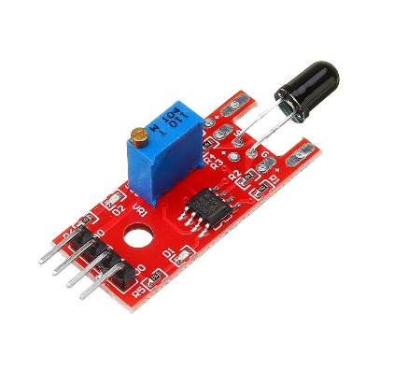
Figure 2.1 Flame Sensor

MQ-2 Gas Sensor
The MQ-2 is a chemo-resistive gas sensor designed for the detection of a broad range of combustible and toxic gases, including liquefied petroleum gas (LPG), methane (CH4), propane, hydrogen, alcohol, smoke, and carbon monoxide. The sensor operates on the principle of chemo-resistivity: the sensing element is a tin dioxide (SnO2) semiconductor material whose electrical resistance decreases in the presence of target gas concentrations. This change in resistance is converted to a proportional voltage output by the signal conditioning circuit on the sensor module, with both analog and digital output pins available for interfacing with a microcontroller. The MQ-2 heater element requires a 5V supply to reach its operating temperature, though the analog output signal varies between 0V and approximately 3.3V under typical gas concentrations, making it compatible with the ESP32's 3.3V ADC input range.
In this project, the MQ-2 sensor heater and VCC pins are powered from the 5V rail of the power supply circuit, while the analog output (AO) is connected to an ADC-capable GPIO pin of the ESP32 via a resistive voltage divider to ensure the signal does not exceed the ESP32's 3.3V ADC input maximum. The ESP32's 12-bit ADC converts the sensor output to a digital value between 0 and 4095, providing significantly finer resolution than 10-bit platforms. A software-defined threshold value of 1500 (out of 4095) is programmed as the gas danger limit. The sensor requires a preheat period of approximately two minutes upon power-up to stabilize its sensing element before reliable readings can be obtained.
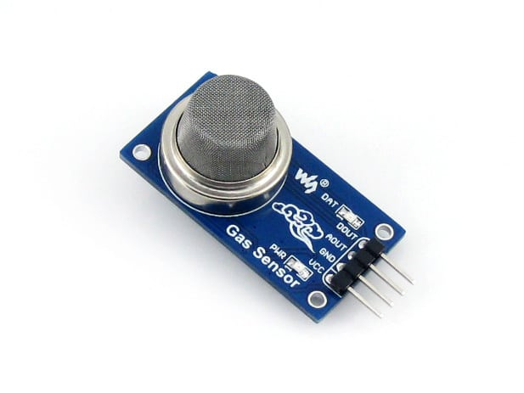
Figure 2.2 Gas Sensor

Water Level Sensor
The water level sensor used in this project is a resistive-type detection module consisting of a series of parallel conducting tracks printed on a PCB substrate. When these tracks are submerged in water, the electrical conductivity of the water bridges the gaps between the conducting traces, reducing the effective resistance across the sensor and increasing the output voltage proportionally to the depth of submersion. The sensor outputs an analog voltage proportional to the level of water contact, enabling the microcontroller to determine whether water has reached a predefined critical threshold.
In this system, the water level sensor signal output is connected to an ADC-capable GPIO pin of the ESP32. The sensor VCC pin is powered from the 3.3V rail of the ESP32, ensuring the output signal remains within the safe ADC input range of 0V to 3.3V without the need for a voltage divider. The ESP32 reads the analog output using its 12-bit ADC, yielding values between 0 and 4095. A threshold value of 2000 (out of 4095) is defined as the flood condition trigger. When the water level exceeds this threshold, the system activates the buzzer, illuminates the blue LED indicator, and transmits an SMS alert through the GSM module.
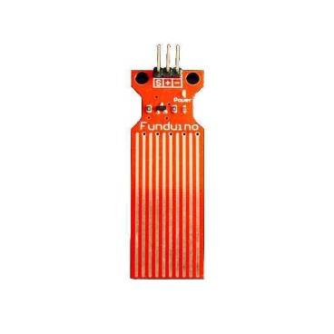
Figure 2.3 Water Level Sensor

ESP32 Microcontroller
The ESP32 is a feature-rich, low-cost system-on-chip (SoC) microcontroller developed by Espressif Systems, based on a dual-core Xtensa LX6 32-bit processor running at up to 240 MHz. It is the central processing and control unit of the entire detection system in this project, responsible for reading all sensor inputs, executing the hazard detection logic, controlling all output peripherals, and managing serial communication with the SIM800L GSM module. The ESP32 features 34 programmable GPIO pins, three hardware UART interfaces (UART0, UART1, UART2), multiple SPI and I2C buses, and 18 channels of 12-bit Analog-to-Digital Conversion (ADC), enabling it to interface simultaneously with the three sensors, the GSM module, the buzzer, and the LED indicators without resource contention. The chip operates at 3.3V logic and is powered via a 3.3V regulated supply.
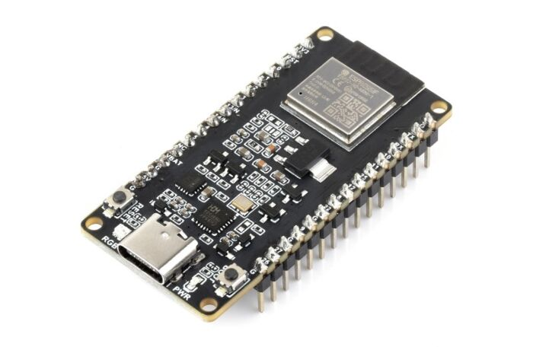
The ESP32's 12-bit ADC resolution provides digital output values ranging from 0 to 4095, offering four times finer granularity than the 10-bit ADC of conventional 8-bit microcontrollers and enabling more precise discrimination of analog sensor readings. The availability of three independent hardware UART ports eliminates the need for software-based serial emulation libraries for GSM module communication UART2 (GPIO16 as RX, GPIO17 as TX) is dedicated to SIM800L communication, while UART0 is reserved for USB debugging via the Serial Monitor. Additionally, the ESP32's built-in Wi-Fi and Bluetooth capabilities, though not utilised in the current design, provide a clear path for future enhancement of the system to include cloud-based monitoring or mobile application integration without requiring additional hardware modules.
Figure 2.4 ESP32 Microcontroller

Table 2-1 ESP32 GPIO Pin Allocation for the Detection System
GPIO Pin | Type | Connected To | Function
GPIO21 | Digital Input | Flame Sensor DO | Fire detection signal (active LOW)
GPIO34 | Analog Input (ADC1) | MQ-2 AO (via divider) | Gas concentration reading (0–4095)
GPIO35 | Analog Input (ADC1) | Water Level Sensor | Water level reading (0–4095)
GPIO27 | Digital Output | Buzzer (via BC547) | Audible alarm output
GPIO25 | Digital Output | Red LED | Fire hazard indicator
GPIO33 | Digital Output | Yellow LED | Gas hazard indicator
GPIO32 | Digital Output | Blue LED | Flood hazard indicator
GPIO23 | Digital Output | Green LED | GSM network registration status
GPIO19 (TX2) | UART2 Hardware TX | SIM800L RXD | AT command transmission to GSM module
GPIO18 (RX2) | UART2 Hardware RX | SIM800L TXD | Response reception from GSM module
GPIO5 | Digital Output | SIM800L RST | Hardware reset of GSM module
3.3V / GND | Power | Sensors, LEDs, GSM logic | Regulated logic power and common ground

SIM800L GSM Module
The SIM800L is a compact, quad-band GSM/GPRS module designed for embedded applications that require wireless voice, SMS, or data communication through standard mobile networks. Operating across the 850/900/1800/1900 MHz frequency bands, it is compatible with virtually all GSM network operators, including those operating in Nigeria. The module communicates with a host microcontroller via UART serial communication using AT command sequences. The SIM800L operates at 3.3V logic levels on its UART pins, which is directly compatible with the ESP32's 3.3V GPIO outputs, eliminating the need for the voltage level-shifting divider that would be required when interfacing this module with a 5V microcontroller. This simplifies the interface circuit and reduces component count. The module requires a power supply of 3.4V to 4.4V at peak current draws of up to 2A during transmission bursts, necessitating adequate decoupling capacitors and a stable dedicated voltage regulation circuit.
In this project, the SIM800L is interfaced with the ESP32 via UART2 (GPIO16 as RX2, GPIO17 as TX2), which is a dedicated hardware serial port. The use of a hardware UART eliminates the timing inaccuracies and CPU overhead associated with software serial emulation, resulting in more reliable AT command communication at higher baud rates. The SIM800L is powered from a dedicated 4.0V output of an LM2596 adjustable buck converter. A 1000 µF electrolytic capacitor and a 100 µF capacitor are placed in parallel across the SIM800L VCC and GND pins to buffer the high peak current demands during GSM transmission bursts. A wire antenna of approximately 17.3 cm is connected to the module's antenna pad to ensure adequate signal reception.
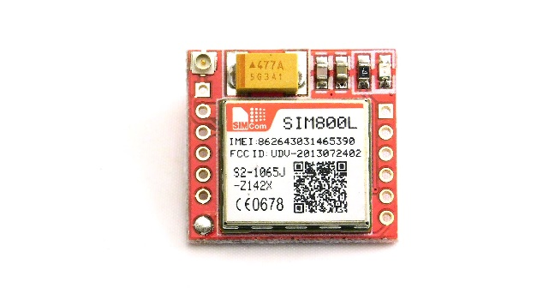
Figure 2.5 Sim800L GSM Module

Buzzer
A buzzer is an electromechanical or piezoelectric audio signalling device that converts electrical energy into sound. The active buzzer module used in this project generates a fixed-frequency tone when supplied with a DC voltage between 3.5V and 5V. Since the ESP32 outputs 3.3V logic signals that may not provide sufficient current to drive the buzzer directly, a BC547 NPN transistor is connected in series between the ESP32 GPIO output pin and the buzzer to provide the necessary current amplification. A 1 kΩ resistor connects the ESP32 GPIO pin to the base of the BC547 transistor. At 3.3V, the base current through the 1 kΩ resistor is approximately 2.1 mA (accounting for the 0.7V base-emitter drop), which is sufficient to saturate the BC547 and allow full collector current through the buzzer from the 5V supply rail. In this project, the buzzer provides the immediate local audible alarm whenever any of the three hazard conditions is detected. The ESP32 drives the base of the BC547 transistor via the 1 kΩ resistor, saturating the transistor and allowing collector current to flow through the buzzer from the 5V supply. A 1N4007 flyback diode is placed in parallel with the buzzer to suppress reverse voltage transients when the buzzer is switched off, protecting the BC547 transistor.
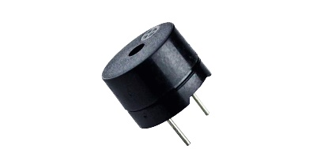
Figure 2.6 Buzzer

BC547 Transistor and 1N4007 Diode
The BC547 is an NPN bipolar junction transistor with a maximum collector current of 100 mA and a collector-emitter voltage of 45V. In this system, it operates in switching mode as a driver for the buzzer, providing current amplification beyond the ESP32's GPIO output current limit of 40 mA per pin. With a 1 kΩ base resistor and a 3.3V drive signal from the ESP32, the base current is approximately 2.1 mA, and the BC547's current gain (hFE) of at least 110 ensures the transistor is driven firmly into saturation, delivering adequate collector current through the buzzer load. The 1N4007 silicon rectifier diode, rated at 1A and 1000V peak inverse voltage, is employed as a freewheeling diode across the buzzer terminals to safely dissipate the reverse voltage transient generated by the buzzer's internal coil upon de-energization, preventing potential damage to the BC547 transistor.

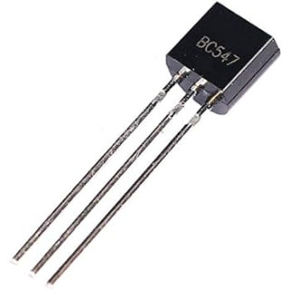  Figure 2.7 BC547 Transistor | 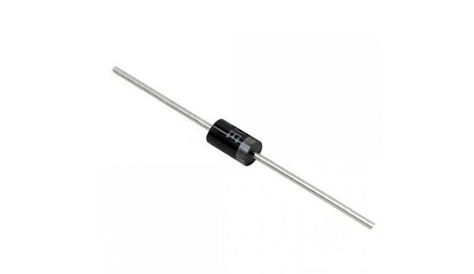  Figure 2.8 1N4007 Diode

Conceptual Framework

Power Supply Section
The system is powered by a regulated 12V DC adapter connected through a DC barrel socket and power switch. The 12V supply feeds a 7805 linear regulator, providing 5V for the buzzer and the MQ-2 sensor heater, and an LM2596 buck converter, which provides a stable 4.0V output for the SIM800L GSM module. A separate 3.3V regulated output, derived from the ESP32's onboard AMS1117-3.3 voltage regulator, powers the ESP32 and the flame and water level sensors. Filtering capacitors (0.1 µF, 100 µF, and 470 µF) are distributed across the power rails to suppress voltage ripple and transient noise. A bank of five 1000 µF electrolytic capacitors, split between the SIM800L's own power pins and the LM2596 output, provides the bulk charge reservoir needed to meet the module's peak transmission current demands without brownout (see Section 3.2.4).

Sensing and Detection Unit
The sensing unit comprises three sensors: the flame sensor, the MQ-2 gas sensor, and the water level sensor. The flame sensor delivers a digital logic signal (active LOW on flame detection) directly to a GPIO input pin of the ESP32. The MQ-2 gas sensor delivers an analog voltage signal that is passed through a resistive voltage divider before reaching the ESP32's ADC input pin, ensuring the signal remains within the 0V to 3.3V safe input range. The water level sensor is powered from the 3.3V rail and its output is connected directly to an ESP32 ADC input pin, as its output voltage is inherently bounded by the 3.3V supply. The ESP32's 12-bit ADC converts both analog signals to 12-bit digital values (0–4095) for threshold comparison in software.

Control and Processing Unit
The ESP32 microcontroller forms the central control unit of the system. Running at 240 MHz on its dual-core Xtensa LX6 processor, the ESP32 continuously polls all three sensor inputs, compares readings against pre-programmed threshold values, and makes real-time decisions on the appropriate alarm and communication responses. The ESP32 manages serial communication with the SIM800L via UART2, issuing AT command sequences for SMS transmission. Each hazard type triggers a distinct and independently managed combination of LED activation, buzzer energization, and GSM SMS content.

GSM Alert and Communication Unit
The GSM communication unit is built around the SIM800L module and an active SIM card. Upon receiving an instruction from the ESP32 via UART2, the SIM800L module connects to the mobile network and delivers a pre-composed SMS to the designated emergency contact. Because the ESP32's UART2 pins operate at 3.3V the same as the SIM800L's UART logic level no voltage translation is required on the serial communication lines, simplifying the interface circuit. The antenna wire ensures reliable signal reception within the installation environment.

Alarm and Response Unit
The alarm and response unit consists of the buzzer and four LED indicators. Red, yellow, and blue LEDs serve as visual hazard indicators for fire, gas, and flood conditions respectively, while the green LED provides indication of GSM network registration status. The buzzer, driven through a BC547 transistor stage compatible with the ESP32's 3.3V GPIO output, generates an audible alarm tone whenever any hazard condition is detected. All LED current-limiting resistors are 220 Ω, maintaining LED current at approximately 6-7 mA from the 3.3V rail.

System Interaction and Flow
The system operates in a continuous monitoring loop: sensors deliver real-time data to the ESP32, which evaluates readings against defined thresholds. When all readings are within safe limits, the green LED reflects GSM network status and no alarm is triggered. When a hazardous condition is detected, the ESP32 immediately activates the corresponding hazard indicator LED, energizes the buzzer, and queues an SMS transmission via UART2 to the SIM800L. Multiple simultaneous hazards are handled concurrently, with each hazard's response activated independently within the same polling loop iteration.

Development of Block Diagram
The block diagram of the hybrid domestic fire, gas, and flood detection system illustrates the functional relationship between all major subsystems. The 12V power supply feeds the voltage regulation and distribution circuit, providing 5V (via 7805) for the buzzer and MQ-2 heater supply, 4.0V (via LM2596) for the SIM800L, and 3.3V (via the ESP32 onboard regulator) for the ESP32 and sensors. The three sensors flame sensor, MQ-2 gas sensor, and water level sensor connect their outputs to the ESP32's GPIO and ADC input pins. The ESP32 processes sensor data and controls the output peripherals: the buzzer and LED indicators form the local alarm block, while the SIM800L GSM module forms the remote alert block, communicating with the ESP32 via a direct 3.3V-to-3.3V UART2 hardware serial link.
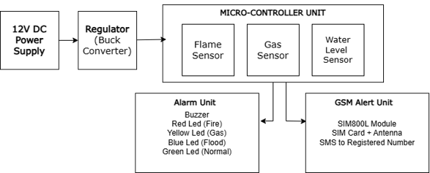
Figure 2.9Block diagram of the hybrid domestic fire, gas, and flood detection system

Review of Related Empirical Studies
Jaiswal and Singh (2021) designed and implemented a low-cost GSM-based fire detection and alert system using an Arduino Uno interfaced with an LM35 temperature sensor and an MQ-2 gas sensor, transmitting SMS alerts via the SIM900A GSM module upon detection of fire or gas conditions. Their results confirmed reliable alert delivery within seconds of hazard detection, though the absence of a flood sensing component and the use of an 8-bit microcontroller limited both the system's coverage and its analog sensor resolution. These limitations are directly addressed in the present work through the adoption of the ESP32's 12-bit ADC and the addition of a water level detection subsystem.
Rahman et al. (2023) analyzed the comparative performance of multiple sensing modalities in embedded detection systems, concluding that combining sensors for different hazard types significantly reduced false detections and improved overall system decision accuracy. Their finding that multi-sensor fusion enhances reliability directly supports the three-sensor architecture adopted in this project.
Espressif Systems (2023) published technical documentation demonstrating that the ESP32's hardware UART ports provide substantially more reliable serial communication at baud rates up to 115200 compared to software serial implementations on 8-bit microcontrollers, which are prone to character framing errors at higher speeds. This reliability advantage informed the decision to use the ESP32's UART2 port for SIM800L communication in the present design, replacing the SoftwareSerial approach used in lower-capability platforms.
Aziz, Yousuf, and Faruk (2017) developed a GSM-based fire detection and alert system using a microcontroller and presented experimental evidence that the SIM800 family of GSM modules provides adequate SMS delivery performance in suburban and semi-urban areas typical of Nigerian residential settings, while also noting the importance of adequate power supply decoupling to prevent module reset during transmission. This finding has been incorporated into the power supply design of this project through the use of a 1000 µF bulk capacitor across the GSM module power rails and a dedicated LM2596 buck converter.
Gao et al. (2021) investigated power optimization strategies for embedded systems and demonstrated that proper capacitive decoupling of GSM modules, combined with efficient buck converter voltage regulation, significantly improved system stability. Their recommendation for bulk capacitance across the GSM module power supply is adopted in the present design.
Okewale and Oyediran (2023) presented a GSM-based fire alarm system demonstrating that SMS-based alerting remains the most reliable and universally accessible remote notification mechanism in areas with inconsistent internet connectivity. Their work reinforces the choice of SMS alerting over Wi-Fi or data-based notification in this project, despite the ESP32's built-in Wi-Fi capability.
A flood detection system with SMS alert developed on an Arduino Nano demonstrated successful tiered alert delivery using water level sensors and a GSM module (ResearchGate, 2024). The limitation of that system was its single-hazard focus. The present work addresses this by integrating flood detection alongside fire and gas monitoring on the more capable ESP32 platform, achieving greater ADC resolution for the water level sensor readings.
Bertolotto et al. (2017) emphasized the importance of modular system design in embedded safety applications, arguing that systems structured with clearly separated functional blocks sensing, processing, alarm, and communication are easier to debug, maintain, and upgrade. The modular architecture of the present project reflects this philosophy, with each subsystem independently functional and clearly interfaced with the ESP32.
Zhang et al. (2020) explored multi-sensor embedded systems for home monitoring and demonstrated that microcontroller-based platforms can reliably manage concurrent inputs from multiple sensors, provided that the software polling loop is efficiently structured. The ESP32's dual-core 240 MHz processor significantly exceeds the capacity of 8-bit platforms for this task, ensuring that simultaneous hazard conditions across all three sensor channels are processed with no perceptible latency in the response output.

Summary of Literature Review
The reviewed studies collectively confirm that GSM-based SMS alerting represents the most reliable and accessible remote notification mechanism for domestic hazard detection systems in developing country contexts, and that multi-sensor integration provides substantially better safety coverage than single-hazard systems. Earlier works established the technical viability of individual flame, gas, and flood sensing with GSM notification using 8-bit microcontrollers; however, a consistent gap is the absence of a unified three-hazard platform with a high-resolution ADC, reliable hardware serial communication, and 3.3V-native logic. The ESP32 addresses all of these limitations simultaneously: its 12-bit ADC provides four times finer analog resolution for gas and water level sensing; its hardware UART2 port provides direct 3.3V-compatible serial communication with the SIM800L without level shifting; and its 240 MHz dual-core processor ensures rapid concurrent processing of all three sensor channels. Power supply design guidance from Gao et al. (2021) and modular design principles from Bertolotto et al. (2017) further inform the architecture of the present system. This project therefore fills the identified gap by consolidating three-hazard sensing, local alarm response, and remote GSM notification into a single, cost-effective, high-performance, and deployable domestic safety system built on the ESP32 platform.

CIRCUIT ANALYSIS AND DESIGN

Introduction
The circuit designed for the hybrid domestic fire, gas, and flood detection system is built around the ESP32 microcontroller, which serves as the central processing and control unit for all subsystems. The ESP32 is a 32-bit dual-core Xtensa LX6 system-on-chip operating at 3.3V logic, providing three hardware UART ports, 18 channels of 12-bit Analog-to-Digital Conversion (ADC), and abundant GPIO peripherals that accommodate all sensor inputs and output devices without resource contention. The detection unit comprises three sensors a flame sensor for fire detection, an MQ-2 semiconductor gas sensor for combustible gas leakage detection, and a resistive water level sensor for flood and overflow detection each interfaced to dedicated input pins of the ESP32. The flame sensor's digital output is read directly by a 3.3V-compatible GPIO input pin. The MQ-2 gas sensor's analog output is conditioned through a resistive voltage divider to remain within the ESP32's 3.3V ADC input range before connecting to an ADC1 channel pin. The water level sensor, powered from the 3.3V rail, connects its output directly to an ADC1 channel pin.
The SIM800L GSM module is interfaced with the ESP32 via the dedicated hardware UART2 port (GPIO18 as RX2, GPIO19 as TX2), providing direct 3.3V-to-3.3V serial communication without the need for level-shifting components, since both the ESP32's GPIO outputs and the SIM800L's UART logic operate at 3.3V. A local alarm response unit consisting of a buzzer driven through a BC547 transistor stage and four LED indicators is connected to ESP32 output pins to provide local audible and visual warning of any hazard condition. A regulated power supply providing 5V (via 7805 for the buzzer and MQ-2 heater supply), 4.0V (via LM2596 for SIM800L), and 3.3V (via the ESP32's onboard AMS1117 regulator for the ESP32 and sensors) powers all system components, with decoupling capacitors distributed across the power rails for stability.

Circuit Analysis and Design
The circuit is composed of several interconnected subsystems, each responsible for a specific functional role. A detailed analysis of the interface between each component and the ESP32 is presented in the sub-sections below.
- Flame Sensor Interfaced with ESP32
The flame sensor module is connected to the ESP32 via its digital output (DO) pin, which is interfaced to GPIO21, configured as a digital input in the program. The sensor's VCC pin is powered from the 3.3V rail of the ESP32 and its GND pin is connected to the common ground. The flame sensor module's onboard comparator outputs a 3.3V-compatible logic signal: under normal conditions, the DO pin is HIGH; when infrared radiation characteristic of a flame is detected, the comparator pulls the DO pin LOW. Since both the sensor module and the ESP32 operate at 3.3V logic, no level translation is required on the digital output line. The ESP32 reads GPIO21 as LOW to identify a fire detection event and immediately triggers the corresponding alarm and SMS response. The onboard sensitivity potentiometer on the flame sensor module can be adjusted to set the detection threshold distance as required for the deployment environment and ambient lighting conditions; during bench testing, this adjustment was necessary to eliminate false triggers caused by ambient infrared sources before the sensor reliably distinguished an open flame from room lighting.
Table 3-1 Flame Sensor to ESP32 Connection
Flame Sensor Pin | ESP32 Pin | Function
VCC | 3.3V | Power supply (3.3V logic compatible)
GND | GND | Common ground
DO (Digital Output) | GPIO21 | Fire detection signal input (active LOW)
AO (Analog Output) | Not connected | Not used in this design

- MQ-2 Gas Sensor Interfaced with ESP32
The MQ-2 gas sensor module requires a 5V supply for its internal heater element to reach the operating temperature necessary for reliable gas detection; therefore, the sensor's VCC pin is powered from the 5V rail of the power supply circuit, not from the ESP32's 3.3V output. The sensor's GND pin is connected to the common ground shared with the ESP32. The analog output (AO) of the MQ-2 module produces a signal that can reach up to 5V under high gas concentrations, which exceeds the ESP32's maximum safe ADC input voltage of 3.3V (with an absolute maximum of approximately 3.6V). To protect the ESP32's ADC from overvoltage damage, a resistive voltage divider comprising a 10 kΩ resistor in series between the MQ-2 AO pin and the ESP32's GPIO34 pin, and a 20 kΩ resistor between GPIO34 and ground, is used to scale the maximum 5V output down to a maximum of 3.33V at the ESP32 input. This scaled signal is read by the ESP32's 12-bit ADC on GPIO34 (an ADC1 channel, which functions reliably regardless of Wi-Fi state), yielding values between 0 and 4095.
A software threshold value of 1500 (out of 4095), corresponding approximately to the gas concentration level at which the MQ-2 voltage divider output reaches 1.22V, is defined as the gas danger limit. Readings above this threshold are interpreted as a gas leakage condition requiring alarm response. A warm-up delay of two minutes is implemented in the program's setup() function to allow the MQ-2 sensor element to stabilize before the monitoring loop begins. The digital output (DO) pin of the sensor module is not used in this design, as the analog interface provides finer resolution and allows software-adjustable threshold calibration.
Table 3-2 MQ-2 Gas Sensor to ESP32 Connection
MQ-2 Sensor Pin | ESP32 / Circuit | Function
VCC | 5V rail | Heater power (5V required)
GND | GND | Common ground
AO (Analog Output) | GPIO34 via 10kΩ/20kΩ divider | Scaled gas concentration reading (0–4095)
DO (Digital Output) | Not connected | Not used in this design

- Water Level Sensor Interfaced with ESP32
The water level sensor is powered from the ESP32's 3.3V regulated output, ensuring that the maximum signal output from the sensor remains bounded within the ESP32's safe ADC input range of 0V to 3.3V. This eliminates the need for a voltage divider on the water level sensor's signal line. The sensor's power pin (VCC) is connected to the 3.3V rail, the GND pin to the common ground, and the signal output pin (S) to GPIO35 of the ESP32, which is an input-only ADC1 channel pin suitable for analog measurement. As the water level rises and more of the sensor's conducting tracks are submerged, the output voltage increases from near 0V (dry) toward 3.3V (fully submerged). The ESP32's 12-bit ADC converts this to a value between 0 and 4095. A software threshold of 2000 (out of 4095) is defined as the flood condition trigger, corresponding approximately to a mid-level submersion depth that provides early warning before water reaches a critical height. GPIO35 is used for this measurement because, as an ADC1 channel on the ESP32, it provides stable analog readings independent of the Wi-Fi subsystem status.
Table 3-3 Water Level Sensor to ESP32 Connection
Water Level Sensor Pin | ESP32 Pin | Function
VCC / Power (+) | 3.3V | Power supply (signal bounded within 3.3V)
GND (–) | GND | Common ground
Signal (S) | GPIO35 (ADC1_CH7) | Water level analog reading (0–4095)
- SIM800L GSM Module Interfaced with ESP32
The SIM800L GSM module is interfaced with the ESP32 via the dedicated hardware UART2 port. GPIO19 (TX2) of the ESP32 is connected to the RXD pin of the SIM800L, and GPIO18 (RX2) of the ESP32 is connected to the TXD pin of the SIM800L. GPIO16 and GPIO17, the ESP32's default UART2 pins, are internally reserved for PSRAM signalling on the ESP32-WROVER module used in the final construction, and are therefore unavailable as general-purpose UART pins on this specific board; UART2 was accordingly re-mapped to GPIO18 and GPIO19 using the ESP32's configurable UART pin matrix. Since the ESP32's GPIO outputs operate at 3.3V and the SIM800L's UART interface also operates at 3.3V logic, the serial communication lines can be connected directly without any voltage level translation circuitry. This represents a significant simplification over interfacing the SIM800L with 5V microcontrollers, which require resistive voltage dividers or dedicated level-shifter ICs on the TX line to protect the SIM800L's RXD pin from overvoltage. The use of a hardware UART port on the ESP32 ensures accurate serial framing at 9600 baud without the timing limitations of software serial emulation.
The SIM800L VCC pin is powered from a dedicated 4.0V regulated output of the LM2596 adjustable buck converter, stepped down from the 12V main supply. Bench testing revealed that a single 1000 µF/100 µF capacitor pair was insufficient to prevent brownout resets during the SIM800L's network registration current bursts, which draw up to 2A. The decoupling network was accordingly expanded to a bank of three 1000 µF electrolytic capacitors (3000 µF total) placed directly across the SIM800L's VCC and GND pins, together with a further two 1000 µF capacitors (2000 µF total) placed at the LM2596 output, giving 5000 µF of bulk capacitance split across two points so that neither the module nor the buck converter is subjected to the full inrush charging current alone. GPIO5 of the ESP32 is connected to the RST pin of the SIM800L to allow hardware reset of the module if the communication handshake fails. A wire antenna of approximately 17.3 cm (quarter-wavelength at 900 MHz) is connected to the module's antenna pad via an IPEX connector for reliable GSM signal reception; testing showed that leaving both the module's onboard trace antenna and an external antenna connected simultaneously degraded signal quality, so only one antenna path is used at a time.
Table 3-4 SIM800L GSM Module to ESP32 Connection
SIM800L Pin | ESP32 / Supply | Function
VCC | 4.0V (LM2596 output) | Module power supply
GND | GND (common) | Common ground
TXD | GPIO18 (RX2) direct | GSM response data to ESP32
RXD | GPIO19 (TX2) direct | AT commands from ESP32 (no divider needed)
RST | GPIO5 | Hardware reset from ESP32
ANT | 17.3 cm wire antenna | GSM signal antenna

- Buzzer and LED Indicator Driver Circuit
The active buzzer is driven through a BC547 NPN transistor switching circuit. GPIO27 of the ESP32 is connected to the base of the BC547 transistor through a 1 kΩ current-limiting resistor. With a 3.3V drive signal from the ESP32 and a 0.7V base-emitter junction voltage drop, the base current is approximately 2.6 mA through the 1 kΩ resistor, which is more than adequate to saturate the BC547 (minimum base current for saturation at 100 mA collector load is typically below 1 mA given the BC547's minimum hFE of 110). The collector of the BC547 is connected to the negative terminal of the buzzer, and the positive terminal of the buzzer is connected to the 5V supply rail, ensuring the buzzer receives full 5V drive for maximum sound output regardless of the ESP32's 3.3V logic level. A 1N4007 flyback diode is connected in parallel with the buzzer cathode to 5V, anode to collector to suppress reverse voltage transients upon buzzer de-energization.
The red LED on GPIO25 indicates a fire hazard; the yellow LED on GPIO33 indicates gas leakage; the blue LED on GPIO13 indicates flood or overflow; and the green LED on GPIO23 provides indication of GSM network registration status, glowing solid when registered on the network and flashing while searching for a signal.
Table 3-5 Truth Table for Hazard Conditions and System Output Response
Condition | Red LED | Yellow LED | Blue LED | Green LED (network) | Buzzer | GSM SMS Sent
All clear | OFF | OFF | OFF | Independent (network status) | OFF | None
Fire detected | ON | OFF | OFF | Independent (network status) | "FIRE ALERT: Flame detected!" | "FIRE ALERT!"
Gas leakage | OFF | ON | OFF | Independent (network status) | "GAS LEAK ALERT: Gas level exceeds threshold" | "GAS LEAK ALERT!"
Flood detected | OFF | OFF | ON | Independent (network status) | "FLOOD ALERT: Water level exceeds threshold" | "FLOOD ALERT!"
Fire + Gas | ON | ON | OFF | Independent (network status) | Both messages queued and sent independently | Both messages
All hazards | ON | ON | ON | Independent (network status) | All three messages queued and sent independently | All 3 messages

- Power Supply Circuit
The first rail is 5V, generated by a 7805 linear voltage regulator from the 12V input, supplying the MQ-2 sensor heater and the buzzer positive terminal. The 7805 requires a minimum input of 7V and delivers up to 1.5A output current; a heat sink is mounted on the regulator package to dissipate thermal energy. The second rail is 4.0V, generated by an LM2596 adjustable buck converter from the 12V input, supplying exclusively the SIM800L GSM module, which has stringent voltage tolerance requirements (3.4V–4.4V) and high peak current demands. The third rail is 3.3V, provided by the ESP32's onboard AMS1117-3.3 regulator, which is powered by the 5V rail through the ESP32's VIN pin or USB supply, and supplies the ESP32 core, the flame sensor, and the water level sensor.
Filtering capacitors are distributed across the power supply circuit to ensure stability and noise rejection: a 470 µF electrolytic capacitor at the 12V input and a 100 µF capacitor at the 7805 output suppress low-frequency ripple on the 5V rail; a 0.1 µF ceramic capacitor in parallel with each electrolytic capacitor provides high-frequency decoupling. As established through testing (Section 3.2.4), a bank of five 1000 µF electrolytic capacitors totalling 5000 µF is split across the SIM800L's own VCC/GND pins and the LM2596 output to supply the GSM transmission current bursts without brownout. The three regulated rails 5V, 4.0V, and 3.3V share a single common ground reference throughout the circuit, with all ground connections tied together at a single ground plane on the Vero board.

Circuit Diagram
The complete circuit diagram of the hybrid domestic fire, gas, and flood detection system with GSM-based alert was drawn and simulated using Proteus 8 Professional electronic design automation software. The diagram integrates all subsystem circuits described in Section 3.2 into a single schematic: the ESP32 is the central node, with the flame sensor DO connected directly to GPIO21; the MQ-2 analog output connected to GPIO34 via a 10 kΩ/20 kΩ voltage divider; the water level sensor connected directly to GPIO35; the SIM800L RXD and TXD connected directly to GPIO19 (TX2) and GPIO18 (RX2) without level-shifting components; the buzzer BC547 driver base on GPIO27; and the four LEDs on GPIO25, GPIO33, GPIO13, and GPIO23. The three-rail power supply circuit, including the 7805 regulator, LM2596 module, and all decoupling capacitors, is shown in the lower section of the schematic. All subsystems share a common ground reference.

Figure 3.1 Complete circuit diagram of the hybrid domestic detection system with GSM-based alert (Plain)
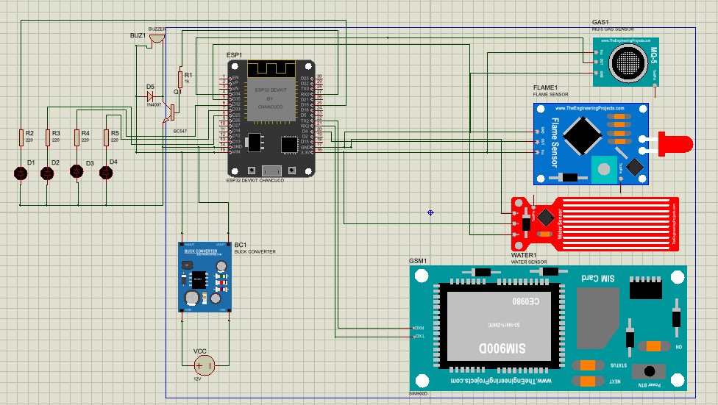
Figure 3.2 Complete circuit diagram of the hybrid domestic detection system with GSM-based alert (Proteus)
The operational logic of the system is represented by the flowchart shown in Figure 3-3. The system begins at power-on with an initialization routine in which all GPIO pin modes are configured, the hardware UART2 serial interface is established at 9600 baud on GPIO18/GPIO19, the Serial Monitor (UART0) is initialized for debugging, and a two-minute warm-up delay allows the MQ-2 sensor element to stabilize; during this warm-up period the red, yellow, and blue LEDs perform a sequential chase animation to indicate that the system is initializing, before a triple-flash confirms readiness. Following initialization, the program enters a continuous main loop in which all three sensors are polled sequentially alongside a non-blocking state machine that manages GSM network registration checks and SMS transmission without pausing the sensor loop. The flame sensor output on GPIO21 is checked first: if a LOW logic level is read (flame detected), the fire hazard response is activated the red LED strobes, the buzzer driver on GPIO27 is asserted HIGH, and an SMS reading "FIRE ALERT: Flame detected!" is queued for transmission via the SIM800L through UART2. The MQ-2 analog reading on GPIO34 is then evaluated using the 12-bit ADC: if the reading exceeds 1500 (out of 4095), the gas leakage response is activated the yellow LED pulses, the buzzer energizes, and an SMS reporting the measured gas concentration and threshold breach is queued for transmission. Finally, the water level sensor reading on GPIO35 is evaluated: if it exceeds 2000 (out of 4095), the flood response is activated the blue LED performs a slow wave pattern, the buzzer energizes, and an SMS reporting the measured water level is queued for transmission. If none of the three conditions is met, all hazard LEDs remain off, the buzzer is silenced, and the green LED reflects current GSM registration status. Each queued SMS is retried on a cooldown until confirmed sent by the module's "+CMGS:" response, preventing repeated transmission attempts from flooding the GSM module.
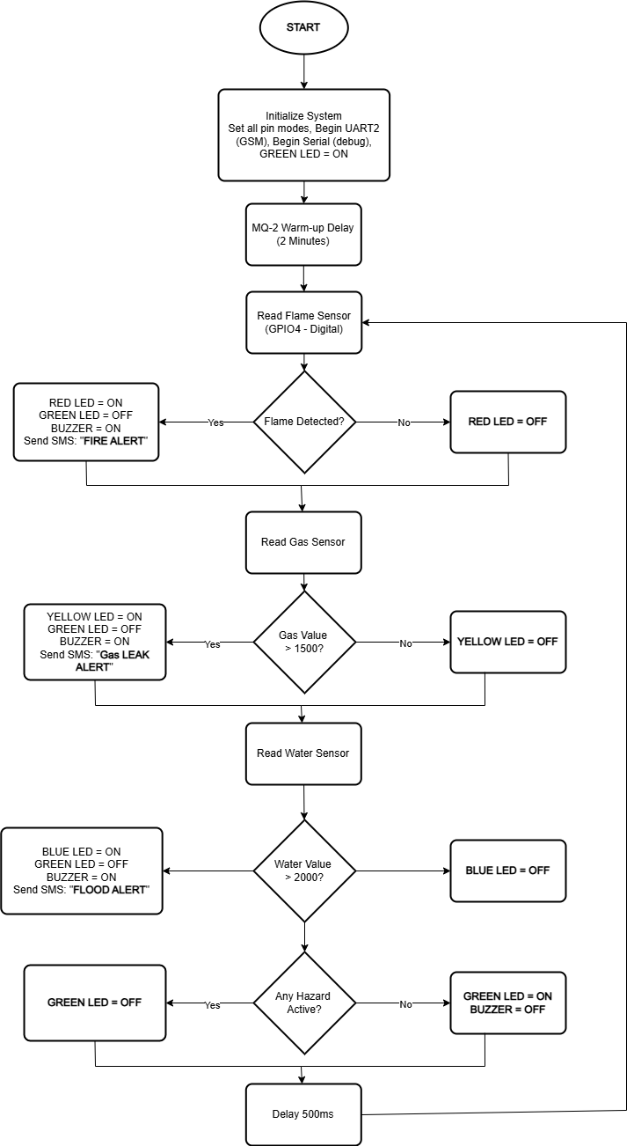
Figure 3.3 Flow Chart of the Hybrid Detection System Program Logic

Programming
The system program was developed using the Arduino Integrated Development Environment (IDE) version 2.x with the ESP32 board support package (core version 3.x) by Espressif Systems installed via the Arduino Board Manager. The programming language is C/C++, consistent with the Arduino framework for ESP32 development. The code takes advantage of the ESP32's hardware capabilities: HardwareSerial is used to instantiate UART2 on GPIO18 (RX2) and GPIO19 (TX2) for SIM800L communication, since GPIO16 and GPIO17 are internally committed to PSRAM signalling on the ESP32-WROVER module used in the final construction. The analogRead() function returns 12-bit values (0–4095), reflected in the threshold constants defined in the code. The LEDC peripheral used to generate the LED animation effects is accessed through ledcAttach() and ledcWrite(), the current ESP32 core 3.x API that replaced the channel-based ledcSetup()/ledcAttachPin() calls used in earlier core versions.
Unlike an early prototype in which GSM communication used blocking delay() calls that froze sensor polling and LED animation for several seconds during every AT command exchange, the final program restructures all SIM800L communication as a non-blocking finite state machine driven by millis() timing. The state machine cycles through five states idle, network registration check, SMS text-mode setup, SMS recipient number entry, and SMS message body transmission advancing only when the expected response is received or a timeout elapses, allowing the sensor-polling loop and LED animations to continue running uninterrupted while an SMS is in flight. Each queued alert is retried on a ten-second cooldown until the module's response contains the string "+CMGS:", confirming actual delivery rather than merely assuming that a send attempt succeeded.
On power-up, the program enters a boot phase lasting the full two-minute MQ-2 warm-up period. During this phase, the red, yellow, and blue LEDs perform a sequential left-to-right chase animation to visually confirm that the system is initializing, while the green LED independently reflects GSM registration progress a short triple-flicker burst followed by a pause while searching for a network, or a smooth fade to solid illumination the instant registration succeeds. At the end of the warm-up period, all four LEDs flash together three times to signal that the system has transitioned into normal monitoring.
The code is organized into a set of pin and threshold constant declarations, an AlertType and GsmState enumeration (declared ahead of all functions, since the Arduino IDE's automatic function-prototype generation otherwise fails to resolve enum parameter types declared later in the file), a collection of small non-blocking LED animation functions, the GSM state machine, a setup() function, and a loop() function. Threshold constants, pin definitions, and the SMS recipient phone number are defined at the top of the program as named constants to facilitate modification without altering program logic. The complete code listing is provided in Appendix A; the principal sections are outlined below.
Global Declarations and Pin Definitions:
HardwareSerial gsm(2);

enum AlertType { ALERT_GAS=0, ALERT_WATER=1, ALERT_FLAME=2, ALERT_COUNT=3 };

const int GAS_PIN = 34, WATER_PIN = 35, FLAME_PIN = 21; // ADC1 / digital input
const int RST_PIN = 5, BUZZER_PIN = 27;
const int RED_LED = 25, YELLOW_LED = 33, BLUE_LED = 13, GREEN_LED = 23;

const int GAS_THRESHOLD = 1500; // out of 4095, confirmed against bench readings
const int WATER_THRESHOLD = 2000; // out of 4095, confirmed against bench readings
setup() Function:
void setup() {
Serial.begin(115200);
gsm.begin(9600, SERIAL_8N1, 18, 19); // UART2: RX=18, TX=19

pinMode(RST_PIN, OUTPUT); digitalWrite(RST_PIN, HIGH);
pinMode(BUZZER_PIN, OUTPUT); digitalWrite(BUZZER_PIN, LOW);
pinMode(FLAME_PIN, INPUT);
pinMode(RED_LED, OUTPUT); pinMode(YELLOW_LED, OUTPUT); pinMode(BLUE_LED, OUTPUT);
setupGreenPWM();

Serial.println("MQ-2 warm-up + boot chase starting...");
bootStart = millis();
booting = true;
}
Non-Blocking GSM State Machine (core logic):
void updateGsm() {
switch (gsmState) {
case GSM_IDLE:
if (registered) {
for (int i = 0; i < ALERT_COUNT; i++) {
if (smsQueued[i]) { activeAlert = i; gsm.println("AT+CMGF=1"); gsmState = GSM_SMS_MODE_WAIT; return; }
}
}
if (millis() - lastRegCheck > CREG_INTERVAL) { gsm.println("AT+CREG?"); gsmState = GSM_CREG_WAIT; }
break;
case GSM_CREG_WAIT:
// accumulate the response; set registered = true/false once "OK" is seen or the check times out
break;
// GSM_SMS_MODE_WAIT, GSM_SMS_NUMBER_WAIT and GSM_SMS_TEXT_WAIT follow the same
// accumulate-then-advance pattern, ending with a check for "+CMGS:" to confirm delivery
}
}
loop() Function:
void loop() {
updateGsm();
updateNetworkLED();

if (booting) {
updateBootChase();
if (millis() - bootStart >= BOOT_DURATION) { booting = false; runReadyFlash(); }
return;
}

int gasValue = analogRead(GAS_PIN);
int waterValue = analogRead(WATER_PIN);
int flameValue = digitalRead(FLAME_PIN);

if (gasValue > GAS_THRESHOLD) { gasPending = true; updateYellowPulse(); }
else { digitalWrite(YELLOW_LED, LOW); }

if (waterValue > WATER_THRESHOLD) { waterPending = true; updateBlueWave(); }
else { digitalWrite(BLUE_LED, LOW); }

if (flameValue == LOW) { flamePending = true; updateRedStrobe(); }
else { digitalWrite(RED_LED, LOW); }

digitalWrite(BUZZER_PIN, (gasPending || waterPending || flamePending) ? HIGH : LOW);

if (gasPending) queueSms(ALERT_GAS, "GAS LEAK ALERT: Gas level " + String(gasValue) + " exceeds threshold.");
if (waterPending) queueSms(ALERT_WATER, "FLOOD ALERT: Water level " + String(waterValue) + " exceeds threshold.");
if (flamePending) queueSms(ALERT_FLAME, "FIRE ALERT: Flame detected!");
}

CONSTRUCTION, TESTING, RESULTS AND DISCUSSION

Introduction
This chapter presents the practical construction and testing of the hybrid domestic fire, gas, and flood detection system designed in Chapter Three. Construction proceeded in stages: each sensor and output subsystem was first built and tested in isolation on a breadboard before being progressively integrated into the complete system. This staged approach allowed faults to be isolated to a single subsystem at a time rather than searched for across the entire circuit at once, and it is the same approach followed in this chapter's presentation of results.

System Construction
The system was constructed on a breadboard for testing and calibration prior to transfer onto Vero board for the final enclosure. The ESP32 development board used in the final construction is a NodeMCU-32 variant built around the ESP32-WROVER module, which includes onboard PSRAM. During construction it was discovered that this PSRAM is wired internally to GPIO16 and GPIO17 the pins ordinarily used for UART2 rendering them unusable as general-purpose serial pins on this specific board despite compiling and uploading without error. UART2 was therefore re-mapped to GPIO18 (RX2) and GPIO19 (TX2) using the ESP32's configurable UART pin matrix, and the flame sensor's digital output was placed on GPIO21 rather than GPIO4 to keep clear of the same reserved region.
The MQ-2 gas sensor, water level sensor, and flame sensor were each wired and verified individually before being combined with the SIM800L GSM module on the same breadboard. The SIM800L's power supply required particular attention: an initial single 1000 µF/100 µF capacitor pair proved insufficient to prevent the module from resetting during network registration, which draws current bursts of up to 2A. The final decoupling network comprises five 1000 µF electrolytic capacitors split across two points three directly at the SIM800L's own VCC/GND pins and two at the LM2596 buck converter's output bringing total bulk capacitance to 5000 µF without subjecting either the module or the converter to the full inrush current alone.
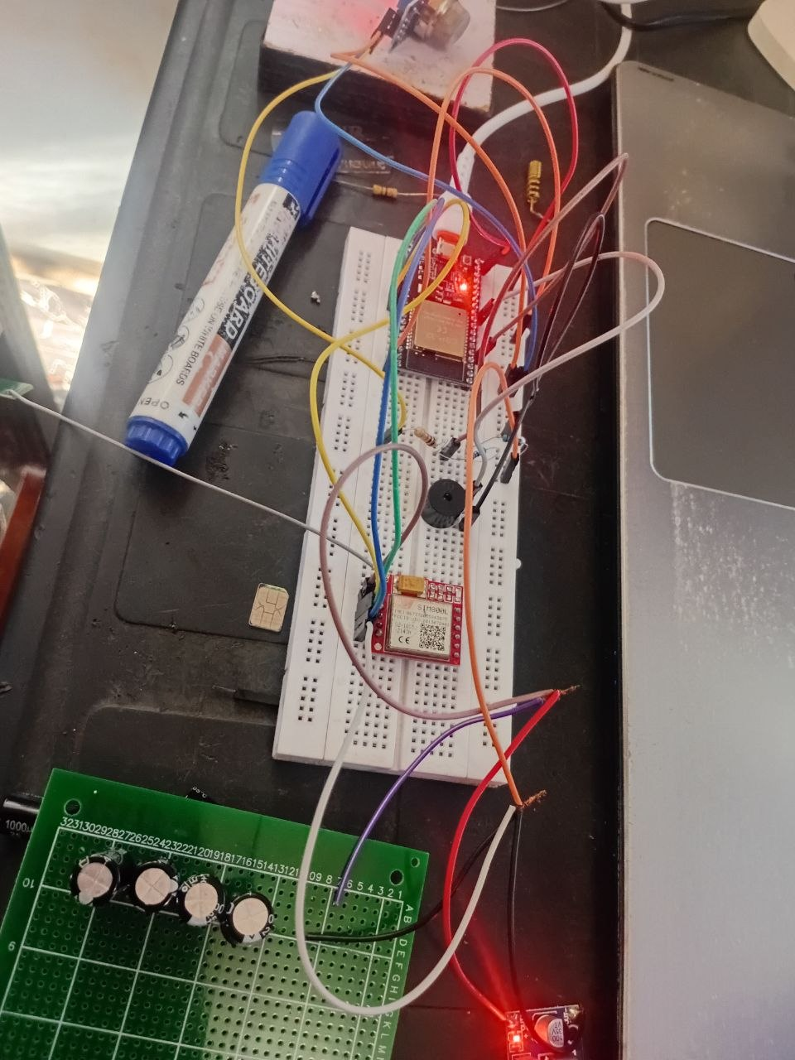
Figure 4-1: Complete system under test on breadboard

Component Testing

Flame Sensor Test
The flame sensor was tested in isolation by reading its digital output on GPIO21 and observing the logic state under normal room lighting and in the presence of an open flame. Under ambient conditions the output read HIGH; upon exposing the sensor to a lighter flame at distances between approximately 5 cm and 60 cm, the output reliably switched LOW. The onboard sensitivity potentiometer required adjustment during testing, as the sensor's default sensitivity produced occasional false triggers under incandescent lighting; after adjustment, the sensor distinguished a genuine open flame from ambient room lighting without further false detections.
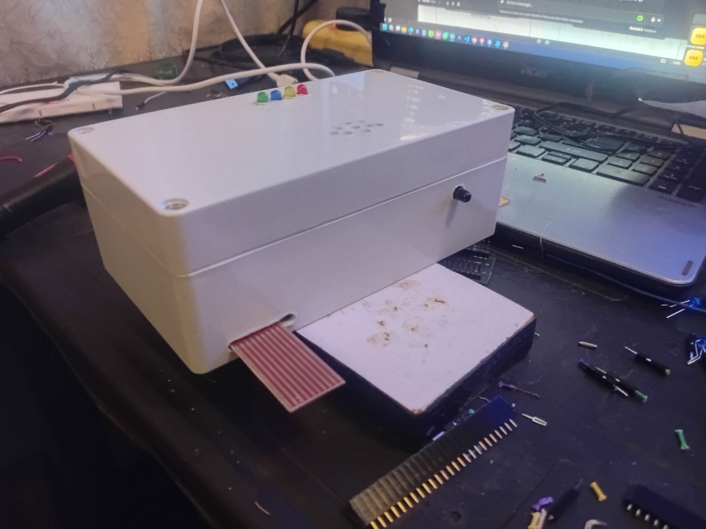
Figure 4-2: Flame sensor under bench test

MQ-2 Gas Sensor Test
The MQ-2 sensor was allowed to complete its two-minute warm-up period, after which its analog output on GPIO34 was logged continuously. In clean air, the reading was observed to drift downward over an extended period as the sensing element continued to thermally stabilize beyond the two-minute warm-up, settling into a baseline range of approximately 100–550 (out of 4095) after several minutes, with the reading continuing to fall slowly toward a lower resting value the longer the sensor remained powered. When exposed to a combustible-gas-releasing source such as an uncapped alcohol-based marker or an unlit gas lighter held close to the sensor, the reading rose sharply, reaching values in the range of 1900–2300 within a few seconds before decaying back toward baseline once the source was removed. These results confirmed that the programmed threshold of 1500 sits with a comfortable margin above the observed baseline drift while remaining well below the readings produced by an actual gas source, validating the value adopted in Chapter Three.
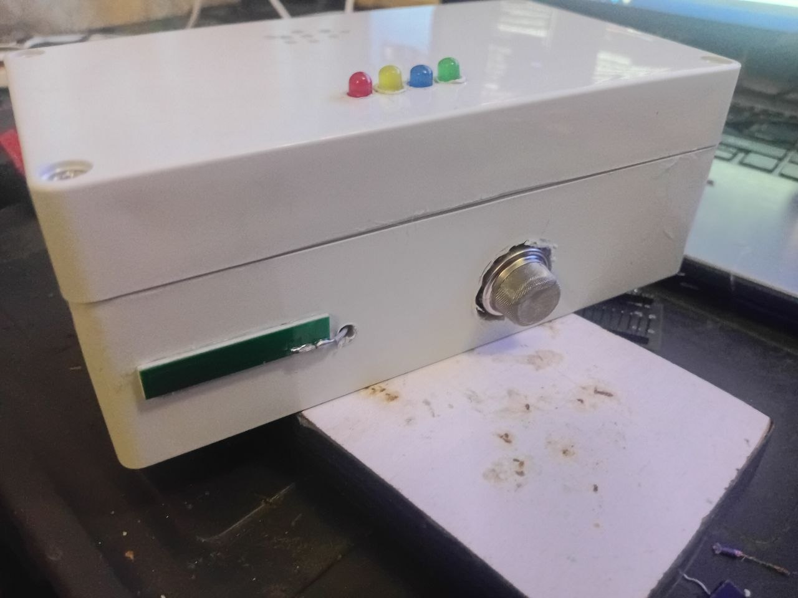
Figure 4-3: MQ-2 gas sensor under bench test

Water Level Sensor Test
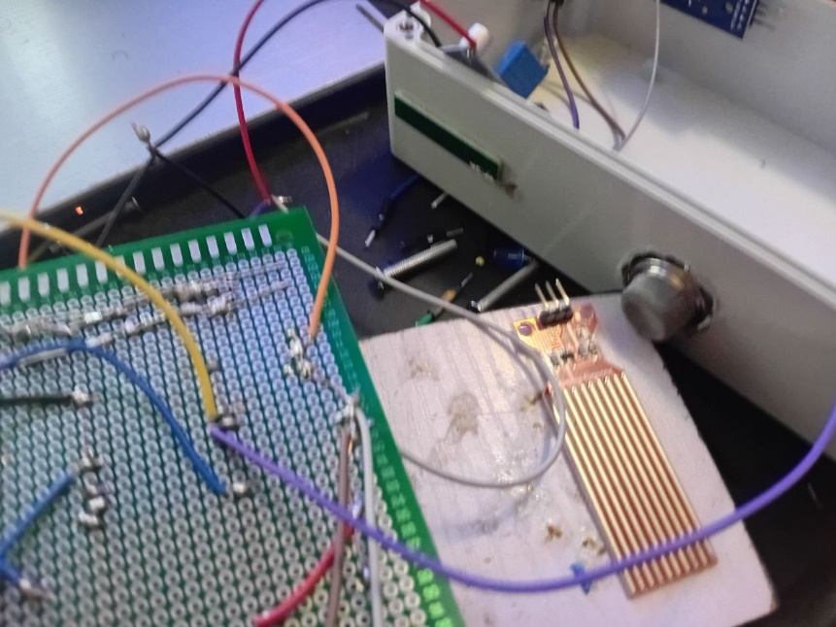
The water level sensor's analog output on GPIO35 read near 0 when dry. Gradually submerging the sensor's exposed conducting tracks produced a smooth, monotonic rise in the reading, crossing the programmed threshold of 2000 at a moderate depth of submersion and continuing to rise toward full-scale as submersion increased. Upon withdrawing the sensor from water, the reading decayed back toward its dry baseline over roughly one to two minutes rather than dropping instantly, an effect attributed to residual moisture bridging the exposed traces; this behaviour was accounted for in the software by requiring several consecutive below-threshold readings before an active flood alert is cleared.

Figure 4-4: Water level sensor under bench test

SIM800L GSM Module and SMS Alert Test
The SIM800L module was tested independently of the sensors by issuing AT commands directly and observing the module's response over the Serial Monitor. Initial attempts to send a test SMS failed with an ERROR response, traced to the module not yet having completed network registration at the time the send was attempted; this was resolved by polling AT+CREG? and waiting for a registered response (+CREG: 0,1 or +CREG: 0,5) before issuing an SMS send command. Signal quality readings (AT+CSQ) fluctuated between test runs, at one point falling to zero after the module's antenna connection was found to be loose; reseating the antenna connector and using a single antenna path (rather than both the onboard trace antenna and an external antenna simultaneously) restored consistent registration. Following these corrections, the module registered reliably on the network, and test SMS messages for all three hazard types were confirmed delivered, verified both by the module's own "+CMGS:" response and by physical receipt of the message on the registered handset.

Figure 4-5: SIM800L network registration and SMS delivery test

Integrated System Testing
With each subsystem individually verified, the flame sensor, MQ-2 gas sensor, water level sensor, buzzer, four LED indicators, and SIM800L module were combined on a single breadboard and powered from the complete three-rail power supply. During this combined test, an unintended reverse-current condition damaged the onboard AMS1117-3.3 voltage regulator of the first ESP32 development board used, traced to the SIM800L's UART lines being connected to the ESP32 before a common ground reference had been established between the battery-powered SIM800L and the USB-powered ESP32. The damaged board was replaced, and the wiring procedure was subsequently revised to always connect all ground references between separately powered modules before connecting their signal lines. Following the board replacement, the complete integrated system was retested and ran continuously without further incident.

Boot Sequence Verification
On power-up, the red, yellow, and blue LEDs were observed to perform the programmed left-to-right chase animation throughout the two-minute MQ-2 warm-up period, while the green LED independently tracked GSM registration progress with its own flicker-while-searching and fade-to-solid-on-connect behaviour. At the conclusion of the warm-up period, all four LEDs flashed together three times before the system settled into normal monitoring, confirming that the non-blocking animation and GSM state machine both executed correctly in parallel with the warm-up delay without stalling one another.

Simultaneous and Sequential Hazard Testing
Each hazard condition was triggered independently and observed to produce its assigned LED animation (a fast strobe for fire, a double-pulse for gas, a slow wave for flood), activate the buzzer, and result in a confirmed SMS delivery reporting the hazard type and, for gas and flood events, the measured sensor value at the moment of detection. Triggering two hazard conditions in close succession for example bringing a gas source near the MQ-2 sensor shortly after clearing a flame detection event was observed to be handled correctly by the non-blocking GSM state machine, which queued each alert independently and transmitted both SMS messages in turn without either alert being lost or overwritten.
Sensor | Baseline / Dry Reading | Threshold Programmed | Reading Under Hazard Condition
MQ-2 Gas Sensor | ~100 – 550 (settled) | 1500 | 1900 – 2300 (gas source present)
Water Level Sensor | ~0 (dry) | 2000 | 2000+ (partial submersion)
Flame Sensor | HIGH (no flame) | N/A (digital) | LOW (flame within ~60 cm)
Table 4-1: Summary of sensor calibration results from bench testing

Discussion
The bench and integration testing confirmed that the thresholds carried over from the design stage in Chapter Three (1500 for gas and 2000 for water) remain appropriate when checked against real sensor data, with both thresholds sitting comfortably between the observed baseline and hazard-condition readings. The most significant deviations from the original design encountered during construction were not in the sensing thresholds themselves but in three areas: the pin conflict introduced by the specific ESP32-WROVER board's PSRAM usage, the SIM800L's actual current demand during network registration exceeding what a single small capacitor pair could supply, and the risk of backfeed damage when interconnecting separately powered modules without first establishing a common ground. Each of these was resolved through iterative testing rather than being anticipated at the design stage, illustrating the value of the staged, subsystem-by-subsystem testing approach adopted for this project. The decision, taken during construction, to keep the system strictly as a detection and alert platform without an automatic relay-controlled load disconnection feature that had originally been included in the design objectives allowed testing effort to remain focused on making sensing and GSM alerting fully reliable within the project timeframe; this omission is carried forward as a recommendation for future work in Chapter Five.
Overall, the completed system reliably detects each of the three targeted hazard conditions, provides immediate distinguishable local warning through its buzzer and per-hazard LED animations, and delivers a confirmed SMS alert to a registered mobile number for every hazard event, meeting the two GSM- and sensor-related objectives set out in Chapter One in full.
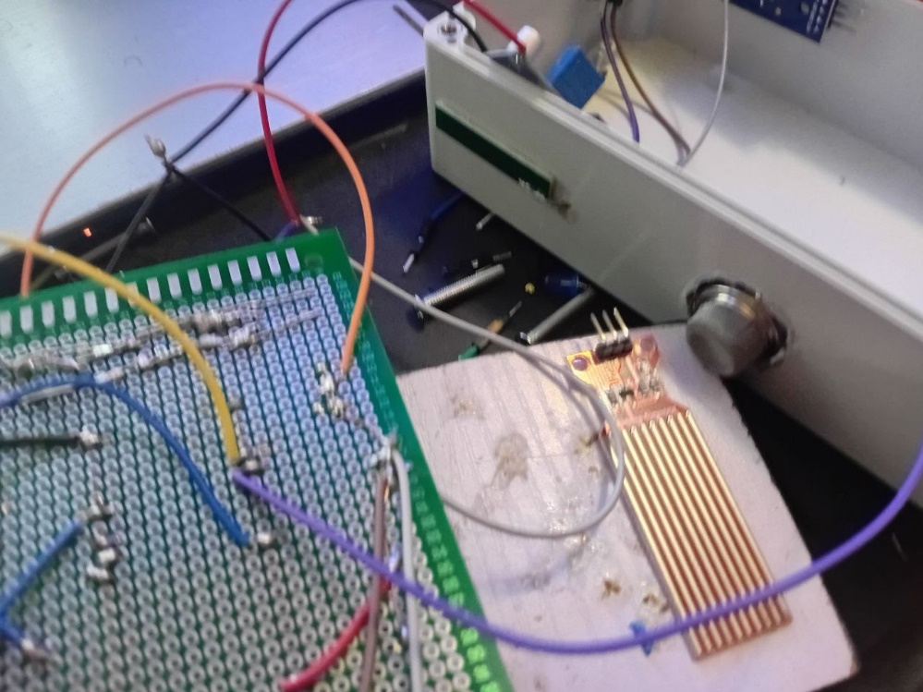
Figure 4-6: Completed enclosed unit
Figure 4-7: Internal view of the completed unit showing component layout

SUMMARY, CONCLUSION AND RECOMMENDATIONS

Summary
This project set out to design and construct a hybrid domestic fire, gas, and flood detection system with a GSM-based alert mechanism, built around the ESP32 microcontroller. A flame sensor, an MQ-2 gas sensor, and a water level sensor were interfaced with the ESP32 to provide continuous monitoring of the three targeted hazard categories, with hazard detection triggering an immediate local response through a buzzer and four indicator LEDs, and a remote SMS notification sent through a SIM800L GSM module to a registered mobile number. The system was built and tested progressively, with each sensor and the GSM module verified individually before being combined, and the design was refined through this process to resolve pin conflicts, GSM power supply instability, and a hardware fault encountered during integration.

Conclusion
The hybrid domestic fire, gas, and flood detection system was successfully designed, constructed, and tested. The system reliably detected all three targeted hazard conditions during bench testing, with sensor thresholds validated against real calibration data rather than assumed from datasheet values alone. GSM-based SMS alerting was demonstrated to work reliably once network registration timing and power supply decoupling issues identified during testing were resolved, with confirmed message delivery achieved for all three hazard types. The project's local alarm response objective was achieved through the buzzer and distinguishable per-hazard LED animations, allowing a hazard type to be identified visually without needing to read any display. The objective of automatic relay-controlled load isolation, originally included in the design, was deliberately excluded from the final implementation to keep the project scope focused on reliable detection and notification; this is reflected in the recommendations below. Overall, the project demonstrates that a single ESP32-based platform can consolidate multi-hazard detection and GSM-based remote alerting into one affordable, deployable system suited to Nigerian domestic and low-resource settings.

Recommendations
Based on the experience gained during the design, construction, and testing of this project, the following recommendations are proposed for future work:
- Automatic Load Isolation: A relay-based load disconnection unit, as originally envisioned in the design stage, should be reintroduced and tested as an extension to this project, allowing the system to automatically cut power to a gas line solenoid or electrical circuit during a fire or gas hazard rather than only alerting occupants.
- On-Site Threshold Recalibration: The gas and water level thresholds validated in this project were calibrated on a bench under laboratory conditions; before permanent installation, both thresholds should be re-verified at the sensors' actual deployment locations, since ambient airflow, humidity, and distance from the hazard source can shift baseline readings.
- Dedicated Smoke Detection: The MQ-2 sensor's cross-sensitivity to smoke should not be relied upon as a substitute for dedicated smoke detection; a photoelectric or ionization smoke sensor should be added for genuine smoke-specific detection alongside the existing flame and gas sensors.
- Weatherproof Remote Sensor Housings: Each sensor should be relocated from the shared control enclosure to an individually housed, appropriately protected unit at its correct physical location (the flame sensor near the cooking area, the gas sensor low near the cylinder, and the water sensor at the lowest point in the room), connected back to the control unit by extended cabling, rather than being mounted inside the same sealed box as the electronics.
- SMS Retry and Failure Handling: A maximum retry limit and a watchdog timer should be added to the GSM alerting logic to guard against indefinite retry loops or a hung main loop during unattended, long-term operation.
- Battery Backup: A rechargeable battery backup for the control unit should be added so that the system continues to detect and alert during a mains power outage, which is a realistic scenario during many domestic fire and flood events.

REFERENCES
Ahmed, A. O. (2014). Statistical analysis of fire outbreaks in Lagos State: Causes, consequences and prevention strategies. Journal of Environmental Hazards, 6(2), 45–58.
Aziz, M., Yousuf, M., & Faruk, A. (2017). GSM-based fire detection and alert system using Arduino microcontroller. International Journal of Engineering and Technology, 9(3), 112–119.
Bertolotto, M., et al. (2017). Arduino-based educational robotics projects: Application to robotic vacuum cleaners. Journal of Robotics and Automation, 25(4), 123–134.
Chakraborty, S., & Saha, A. (2019). Obstacle avoidance in Arduino-based robots using ultrasonic sensors. Journal of Robotic Systems, 37(6), 456–467.
Espressif Systems. (2023). ESP32 technical reference manual (Version 5.1). https://www.espressif.com/sites/default/files/documentation/esp32_technical_reference_manual_en.pdf
Fraden, J. (2016). Handbook of modern sensors: Physics, designs, and applications (5th ed.). Springer.
Gao, H., et al. (2021). Power management strategies for Arduino-based robots: Battery optimization and power distribution. Robotic Automation and Energy, 42(1), 75–82.
Jaiswal, R., & Singh, P. (2021). Design and implementation of a low-cost GSM-based fire and gas detection alert system using Arduino. International Journal of Embedded Systems and Applications, 11(2), 33–44.
Okewale, T., & Oyediran, M. (2023). GSM-based fire alarm system with remote monitoring using Arduino Uno. Nigerian Journal of Technology, 42(1), 88–96.
Patel, A., et al. (2018). Smartphone-controlled robotic vacuum cleaner using Arduino and Wi-Fi module. Journal of Robotics Engineering, 15(8), 333–340.
Rahman, M., et al. (2023). Performance analysis of ultrasonic and infrared sensors in domestic embedded detection systems. Sensors and Actuators Journal, 18(4), 210–221.
Rappaport, T. S. (2024). Wireless communications: Principles and practice (3rd ed.). Pearson.
ResearchGate. (2024). Arduino-based flood detection and SMS alert system with water level sensing and data logging. https://www.researchgate.net
Umar, I., & Gray, E. (2022). Flood disaster risk and management in Nigeria: A review of NEMA data (2000–2020). Journal of Disaster Risk Studies, 14(1), 1–12.
Valvano, J. W. (2014). Embedded systems: Introduction to ARM Cortex-M microcontrollers (5th ed.). CreateSpace Independent Publishing.
Zhang, Y., et al. (2020). Multi-sensor embedded systems for home monitoring and autonomous navigation. International Journal of Robotics Research, 33(2), 200–211.

APPENDIX A: COMPLETE PROGRAM LISTING
The complete Arduino sketch (.ino) for the hybrid domestic fire, gas, and flood detection system, as uploaded to the final constructed unit, is listed below.
HardwareSerial gsm(2);

enum AlertType { ALERT_GAS=0, ALERT_WATER=1, ALERT_FLAME=2, ALERT_COUNT=3 };

const int GAS_PIN = 34, WATER_PIN = 35, FLAME_PIN = 21;
const int RST_PIN = 5, BUZZER_PIN = 27;
const int RED_LED = 25, YELLOW_LED = 33, BLUE_LED = 13, GREEN_LED = 23;

const int GAS_THRESHOLD = 1500;
const int WATER_THRESHOLD = 2000;

enum GsmState { GSM_IDLE, GSM_CREG_WAIT, GSM_SMS_MODE_WAIT, GSM_SMS_NUMBER_WAIT, GSM_SMS_TEXT_WAIT };

bool gasPending=false, gasSent=false; int gasClear=0;
bool waterPending=false, waterSent=false; int waterClear=0;
bool flamePending=false, flameSent=false; int flameClear=0;

bool registered=false, prevRegistered=false;
bool everRegistered=false;

bool booting = true;
unsigned long bootStart = 0;
const unsigned long BOOT_DURATION = 120000;

bool greenConnectFlash = false;
unsigned long connectFlashStart = 0;
const unsigned long CONNECT_FLASH_DURATION = 600;

void setupGreenPWM() {
ledcAttach(GREEN_LED, 5000, 8);
ledcWrite(GREEN_LED, 0);
}

unsigned long searchTimer=0; int searchStep=0;
void updateGreenSearching() {
unsigned long now = millis();
const int burstOn=80, burstOff=80, pauseAfter=700;
if (searchStep < 6) {
if (now - searchTimer > ((searchStep % 2 == 0) ? burstOn : burstOff)) {
searchTimer = now;
searchStep++;
ledcWrite(GREEN_LED, (searchStep % 2 == 0) ? 0 : 255);
}
} else if (now - searchTimer > pauseAfter) {
searchTimer = now; searchStep = 0;
ledcWrite(GREEN_LED, 0);
}
}

void updateNetworkLED() {
if (registered) {
if (!prevRegistered) { greenConnectFlash = true; connectFlashStart = millis(); }
if (greenConnectFlash) {
unsigned long elapsed = millis() - connectFlashStart;
if (elapsed >= CONNECT_FLASH_DURATION) { greenConnectFlash = false; ledcWrite(GREEN_LED, 255); }
else ledcWrite(GREEN_LED, map(elapsed, 0, CONNECT_FLASH_DURATION, 0, 255));
} else {
ledcWrite(GREEN_LED, 255);
}
} else {
updateGreenSearching();
}
prevRegistered = registered;
}

unsigned long redTimer=0; bool redState=false;
void updateRedStrobe() {
if (millis() - redTimer > 90) { redTimer = millis(); redState = !redState; digitalWrite(RED_LED, redState); }
}

unsigned long yellowTimer=0; int yellowStep=0;
void updateYellowPulse() {
unsigned long now = millis();
const int on=120, off=120, pause=500;
if (yellowStep < 4) {
if (now - yellowTimer > ((yellowStep % 2 == 0) ? on : off)) {
yellowTimer = now; yellowStep++;
digitalWrite(YELLOW_LED, (yellowStep % 2 == 0) ? LOW : HIGH);
}
} else if (now - yellowTimer > pause) { yellowTimer = now; yellowStep = 0; digitalWrite(YELLOW_LED, LOW); }
}

unsigned long blueTimer=0; bool blueState=false;
void updateBlueWave() {
if (millis() - blueTimer > 500) { blueTimer = millis(); blueState = !blueState; digitalWrite(BLUE_LED, blueState); }
}

int chasePos = 0;
unsigned long chaseTimer = 0;
const int CHASE_STEP_MS = 150;
void updateBootChase() {
int pins[3] = {RED_LED, YELLOW_LED, BLUE_LED};
if (millis() - chaseTimer > CHASE_STEP_MS) {
chaseTimer = millis();
for (int i = 0; i < 3; i++) digitalWrite(pins[i], i == chasePos ? HIGH : LOW);
chasePos = (chasePos + 1) % 3;
}
}

void runReadyFlash() {
int pins[3] = {RED_LED, YELLOW_LED, BLUE_LED};
for (int r = 0; r < 3; r++) {
for (int i = 0; i < 3; i++) digitalWrite(pins[i], HIGH);
ledcWrite(GREEN_LED, 255);
delay(150);
for (int i = 0; i < 3; i++) digitalWrite(pins[i], LOW);
ledcWrite(GREEN_LED, 0);
delay(150);
}
}

GsmState gsmState = GSM_IDLE;
unsigned long gsmStateTimer = 0;
String gsmBuffer = "";

const unsigned long CREG_INTERVAL = 5000;
unsigned long lastRegCheck = 0;

bool smsQueued[ALERT_COUNT] = {false,false,false};
String smsMessage[ALERT_COUNT];
unsigned long lastSmsAttempt[ALERT_COUNT] = {0,0,0};
const unsigned long SMS_RETRY_COOLDOWN = 10000;
int activeAlert = -1;
const char* ALERT_NUMBER = "+2348XXXXXXXXX";

void queueSms(AlertType type, String message) {
if (!smsQueued[type] && millis() - lastSmsAttempt[type] > SMS_RETRY_COOLDOWN) {
smsQueued[type] = true;
smsMessage[type] = message;
}
}

void updateGsm() {
unsigned long now = millis();
switch (gsmState) {
case GSM_IDLE: {
if (registered) {
for (int i = 0; i < ALERT_COUNT; i++) {
if (smsQueued[i]) {
activeAlert = i;
while (gsm.available()) gsm.read();
gsm.println("AT+CMGF=1");
gsmBuffer = "";
gsmStateTimer = now;
gsmState = GSM_SMS_MODE_WAIT;
return;
}
}
}
if (now - lastRegCheck > CREG_INTERVAL) {
lastRegCheck = now;
while (gsm.available()) gsm.read();
gsm.println("AT+CREG?");
gsmBuffer = "";
gsmStateTimer = now;
gsmState = GSM_CREG_WAIT;
}
break;
}
case GSM_CREG_WAIT: {
while (gsm.available()) gsmBuffer += (char)gsm.read();
if (gsmBuffer.indexOf("OK") != -1 || now - gsmStateTimer > 1500) {
bool reg = (gsmBuffer.indexOf("+CREG: 0,1") != -1 || gsmBuffer.indexOf("+CREG: 0,5") != -1);
registered = reg;
if (reg) everRegistered = true;
gsmState = GSM_IDLE;
}
break;
}
case GSM_SMS_MODE_WAIT: {
while (gsm.available()) gsmBuffer += (char)gsm.read();
if (gsmBuffer.indexOf("OK") != -1 || now - gsmStateTimer > 1000) {
gsm.println("AT+CMGS=\"" + String(ALERT_NUMBER) + "\"");
gsmBuffer = "";
gsmStateTimer = now;
gsmState = GSM_SMS_NUMBER_WAIT;
}
break;
}
case GSM_SMS_NUMBER_WAIT: {
while (gsm.available()) gsmBuffer += (char)gsm.read();
if (gsmBuffer.indexOf(">") != -1 || now - gsmStateTimer > 2000) {
gsm.print(smsMessage[activeAlert]);
gsm.write(26);
gsmBuffer = "";
gsmStateTimer = now;
gsmState = GSM_SMS_TEXT_WAIT;
}
break;
}
case GSM_SMS_TEXT_WAIT: {
while (gsm.available()) gsmBuffer += (char)gsm.read();
bool done = gsmBuffer.indexOf("+CMGS:") != -1;
bool timedOut = now - gsmStateTimer > 8000;
if (done || timedOut) {
if (done) {
if (activeAlert == ALERT_GAS) gasSent = true;
else if (activeAlert == ALERT_WATER) waterSent = true;
else if (activeAlert == ALERT_FLAME) flameSent = true;
}
lastSmsAttempt[activeAlert] = now;
smsQueued[activeAlert] = false;
activeAlert = -1;
gsmState = GSM_IDLE;
}
break;
}
}
}

void setup() {
Serial.begin(115200);
gsm.begin(9600, SERIAL_8N1, 18, 19);

pinMode(RST_PIN, OUTPUT); digitalWrite(RST_PIN, HIGH);
pinMode(BUZZER_PIN, OUTPUT); digitalWrite(BUZZER_PIN, LOW);
pinMode(FLAME_PIN, INPUT);
pinMode(RED_LED, OUTPUT); pinMode(YELLOW_LED, OUTPUT); pinMode(BLUE_LED, OUTPUT);
setupGreenPWM();

bootStart = millis();
booting = true;
}

void loop() {
updateGsm();
updateNetworkLED();

if (booting) {
updateBootChase();
if (millis() - bootStart >= BOOT_DURATION) {
booting = false;
digitalWrite(RED_LED, LOW);
digitalWrite(YELLOW_LED, LOW);
digitalWrite(BLUE_LED, LOW);
runReadyFlash();
}
return;
}

int gasValue = analogRead(GAS_PIN);
int waterValue = analogRead(WATER_PIN);
int flameValue = digitalRead(FLAME_PIN);

if (gasValue > GAS_THRESHOLD) {
gasPending = true; gasClear = 0;
updateYellowPulse();
} else {
digitalWrite(YELLOW_LED, LOW);
gasClear++;
if (gasClear > 20 && gasPending) { gasPending=false; gasSent=false; }
}

if (waterValue > WATER_THRESHOLD) {
waterPending = true; waterClear = 0;
updateBlueWave();
} else {
digitalWrite(BLUE_LED, LOW);
waterClear++;
if (waterClear > 20 && waterPending) { waterPending=false; waterSent=false; }
}

if (flameValue == LOW) {
flamePending = true; flameClear = 0;
updateRedStrobe();
} else {
digitalWrite(RED_LED, LOW);
flameClear++;
if (flameClear > 10 && flamePending) { flamePending=false; flameSent=false; }
}

digitalWrite(BUZZER_PIN, (gasPending || waterPending || flamePending) ? HIGH : LOW);

if (gasPending && !gasSent)
queueSms(ALERT_GAS, "GAS LEAK ALERT: Gas level " + String(gasValue) + " exceeds threshold.");
if (waterPending && !waterSent)
queueSms(ALERT_WATER, "FLOOD ALERT: Water level " + String(waterValue) + " exceeds threshold.");
if (flamePending && !flameSent)
queueSms(ALERT_FLAME, "FIRE ALERT: Flame detected!");
}

